**ARINDA HILLARY**

**DBMS**

**LAB 3: T-SQL**

**3/9/2024**

1. [4]**Write and execute a T-SQL stored procedure Factorial(n), which computes and outputs the factorial of the input parameter n.  If n is negative, then the procedure prints an error message.**

CREATE OR ALTER PROCEDURE getFactorial

@n INT

AS

BEGIN

DECLARE @result BIGINT = 1;

IF @n < 0

BEGIN

PRINT 'Error: Input must be a non-negative number.';

RETURN;

END;

DECLARE @numHolder INT = @n

WHILE @n > 0

BEGIN

SET @result = @result * @n;

SET @n = @n - 1;

END;

PRINT CAST(@numHolder AS VARCHAR(10)) + '! = ' + CAST(@result AS VARCHAR(20));

END;

GO

EXEC getFactorial 5;

GO

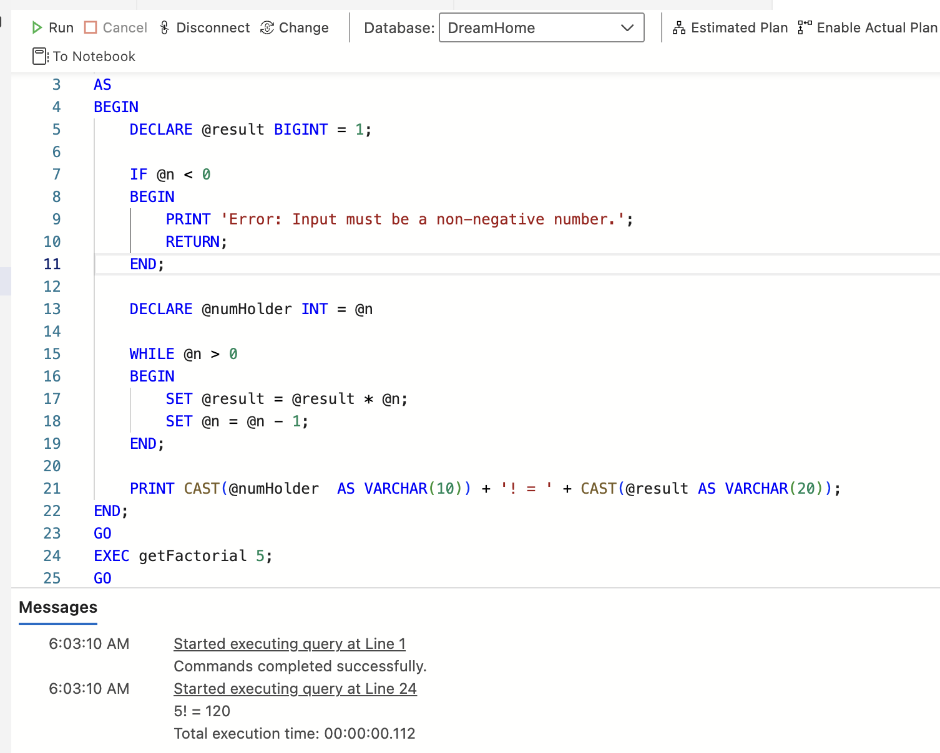

1. [6]**Create a Table Employee with the fields:  social security no.(primary key), name, position, no.of dependents, annual salary.**

**Write and execute a T-SQL procedure Compute_Tax to do the following:**

* **Create a new table Tax with fields:  social security no., income tax.**
* **Fill the table Tax with data by computing the income tax for each person in the Employee Table.**

Income tax is computed from the annual salary S and the number of dependents D.

Net Salary:  S - (7000 + D*950)

Tax Computed as follows:

* 10% of the first 15,000 of net salary;
* plus 15% of the next 15,000 of net salary;
* plus 28% of any net salary over 30,000.

CREATE TABLE Employee (

SSN VARCHAR(11) PRIMARY KEY,

name VARCHAR(20),

position VARCHAR(10),

no_of_dependents INT,

annual_salary money

);

GO

CREATE OR ALTER PROCEDURE Compute_Tax AS

BEGIN

DELETE FROM Employee;

INSERT INTO Employee (SSN, name, position, no_of_dependents, annual_salary)

VALUES

('123-45-6789', 'John Doe', 'Manager', 2, 6000),

('987-65-4321', 'Jane Smith', 'Developer', 1, 20000),

('555-55-5555', 'Jim Brown', 'Analyst', 3, 50000);

IF OBJECT_ID('Tax','U') IS NOT NULL

DROP TABLE Tax;

CREATE TABLE Tax(

SSN VARCHAR(11) PRIMARY KEY,

income_tax money

);

INSERT INTO Tax (SSN, income_tax)

SELECT

e.SSN,

CASE

WHEN net_salary <= 15000 THEN net_salary * 0.10

WHEN net_salary <= 30000 THEN 15000 * 0.10 + (net_salary - 15000) * 0.15

ELSE 15000 * 0.10 + 15000 * 0.15 + (net_salary - 30000) * 0.28

END AS income_tax

FROM

(SELECT

SSN,

annual_salary - (7000 + no_of_dependents * 950) AS net_salary

FROM Employee) AS e;

END;

GO

EXEC Compute_Tax;

go

SELECT * FROM Tax;

Go

**Employee table**

**Tax table**

